Experiment: Car Booking System using Zoho Creator (SaaS)
Aim
To design and develop a Car Booking System using Zoho Creator, a cloud-based SaaS platform, that enables users to book rental cars, automatically calculates the total rental amount, and maintains booking records efficiently.
Procedure
Step 1:
Log in to Zoho Creator.
Step 2:
Click Create New Application.
Step 3:
Enter the application name as: Car Booking System
Step 4:
Create a form named: Car Booking
Step 5:
Add the following fields:
Field Name | Field Type
Name | Name
Phone | Phone
Car Model | Single Line
Cost of Rent | Currency
Number of Days | Number
Total | Currency
Step 6:
Create a workflow to automatically calculate the total rental amount.
Workflow: On User Input → Number of Days
if(input.COST_OF_RENT != null && input.NUMBER_OF_DAYS != null)
{
input.TOTAL = input.COST_OF_RENT * input.NUMBER_OF_DAYS;
}
Step 7:
Create an On Success workflow to display a booking confirmation message.
alert "🚗 Car Booking Successful!\nThank you for choosing our service.";
Step 8:
Create a report named: Car Booking Report to display all booking details.
Step 9:
Run the application, enter booking details, submit the form, and verify that the total amount is calculated automatically and the booking confirmation message is displayed.
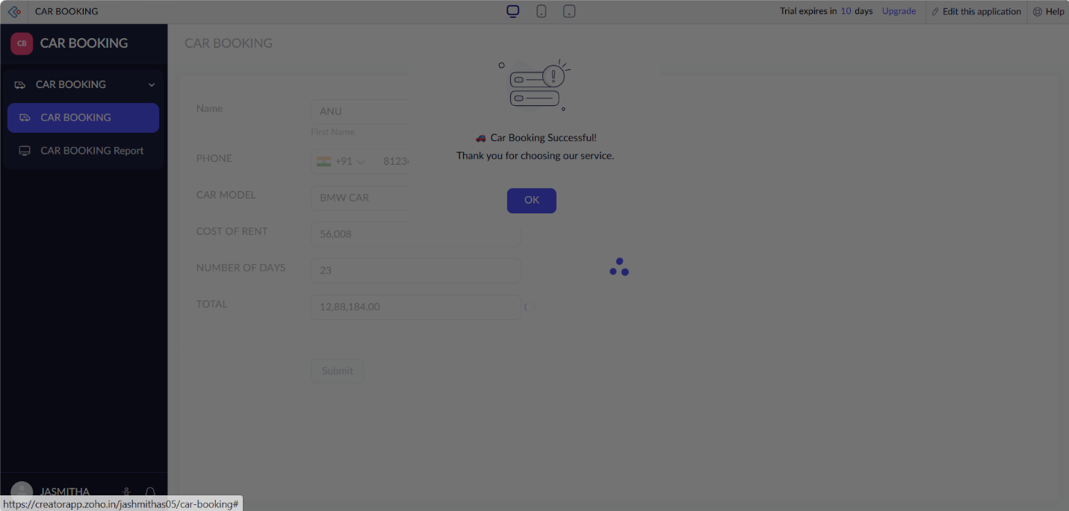
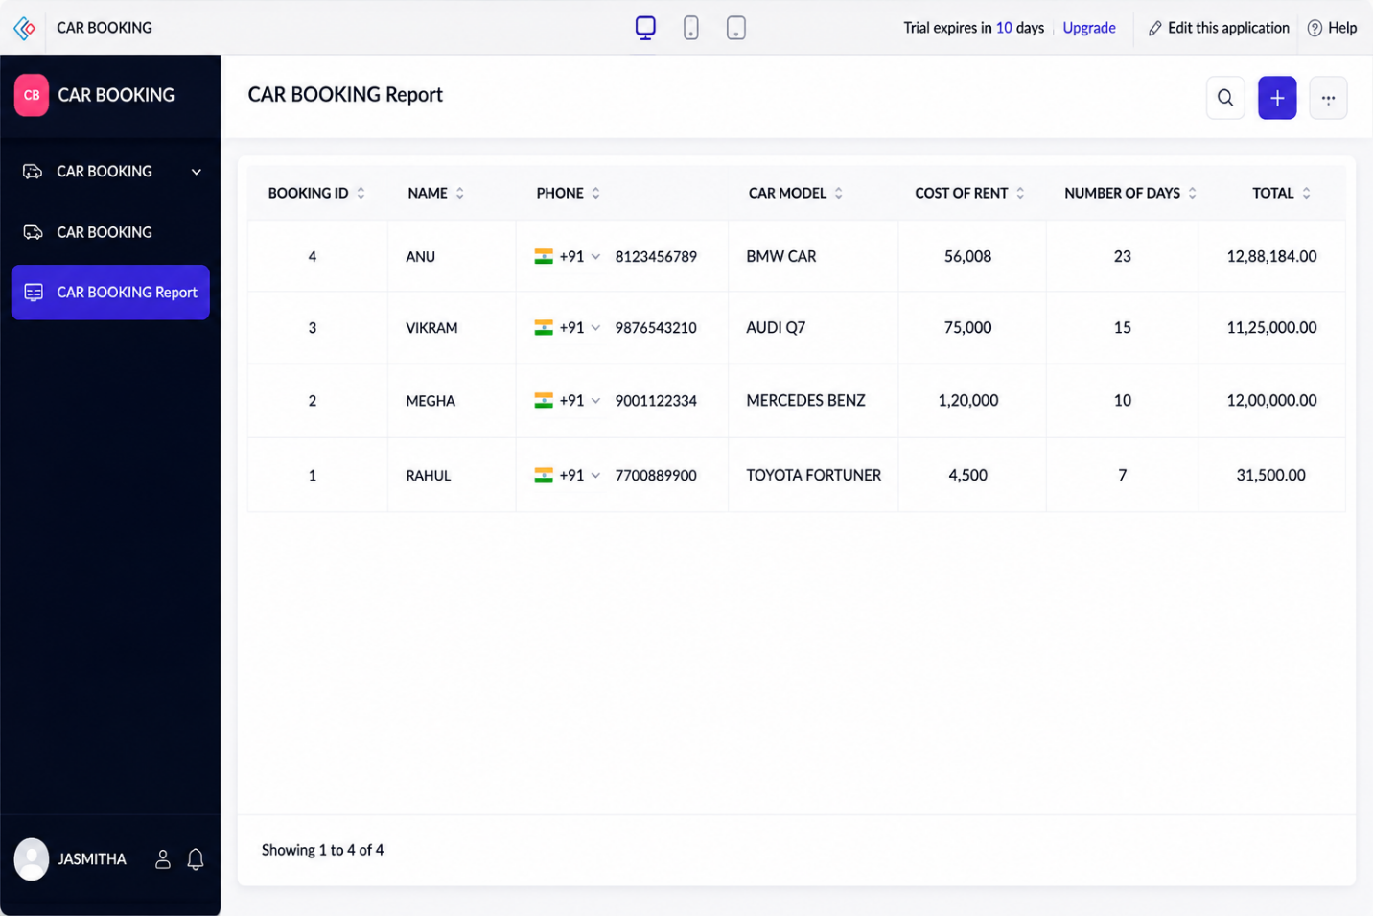
Implementation
The Car Booking System was implemented using Zoho Creator forms, workflows, and reports. The system allows users to enter their personal details, select a car model, specify the rental cost and number of rental days. The total rental amount is automatically calculated based on the cost of rent and number of days using a workflow. After the booking is successfully submitted, a confirmation message is displayed to the user. Reports are generated to store and manage all car booking records efficiently through the Zoho Creator cloud platform.

